**DASHBOARD**

https://public.tableau.com/views/FemaleHeartDiseasePredictor/Story_Board?:language=en-US&publish=yes&:display_count=n&:origin=viz_share_link

Topic: Female Heart Disease

Platform: Tableau

Layout/Planning

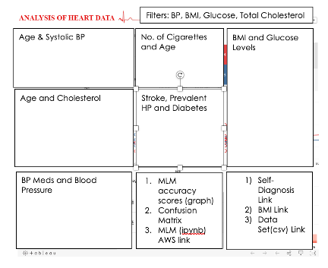

AWS S3 Bucket to store and create links

*Make your heart beat faster…*

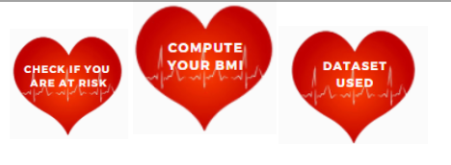

Clean Dataset _Tableau

<https://link-ed.s3.us-east-2.amazonaws.com/Clean_FHD_predictor_dataset_Tableau.htm>

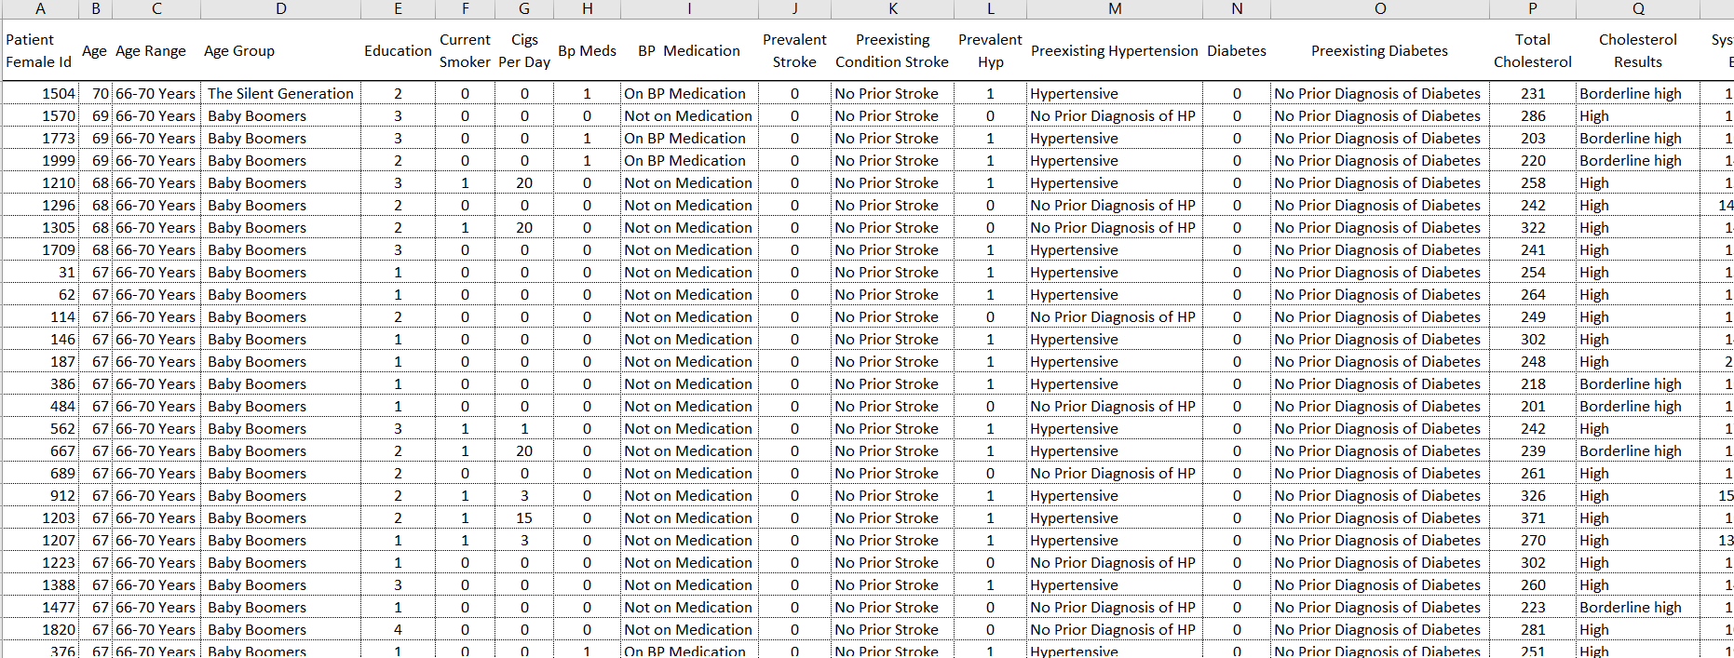

Risk Heart Attack link

<https://www.medindia.net/patients/calculators/risk_heart_attack.asp>

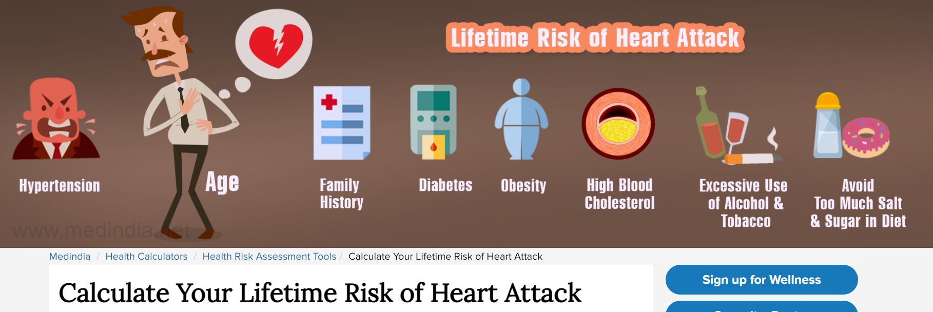

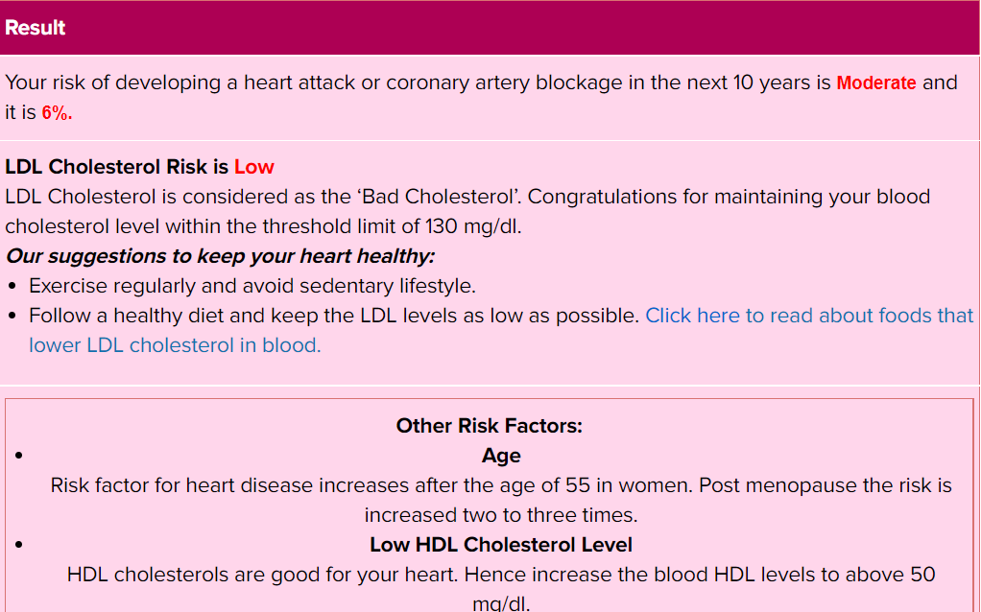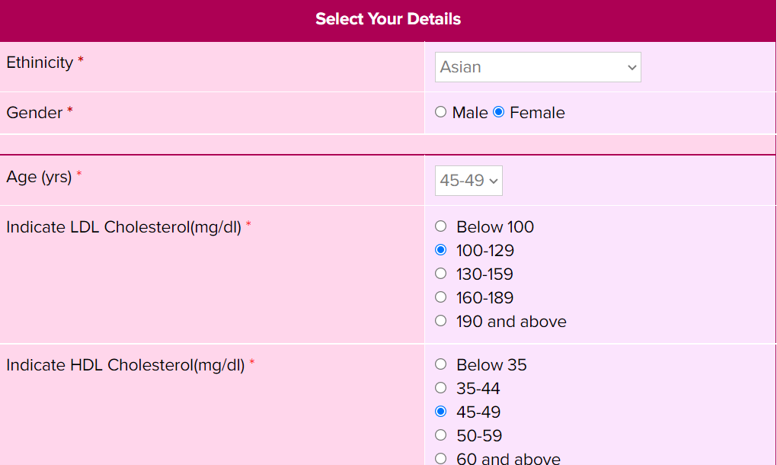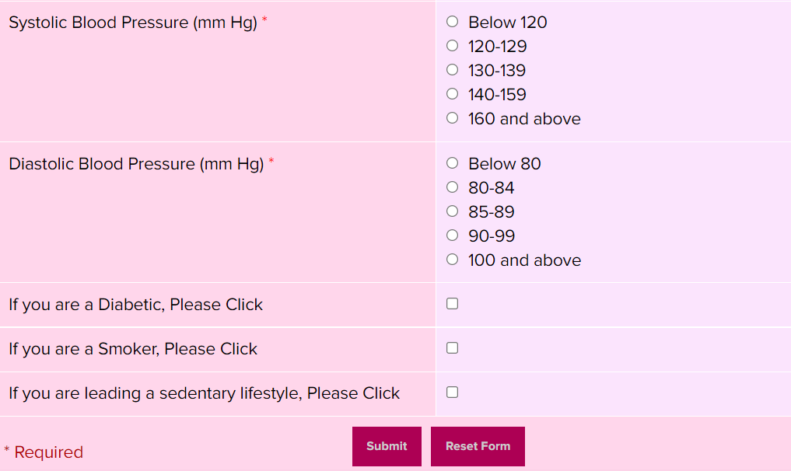

BMI Calculation

<https://link-ed.s3.us-east-2.amazonaws.com/bmi-chart.xlsx>

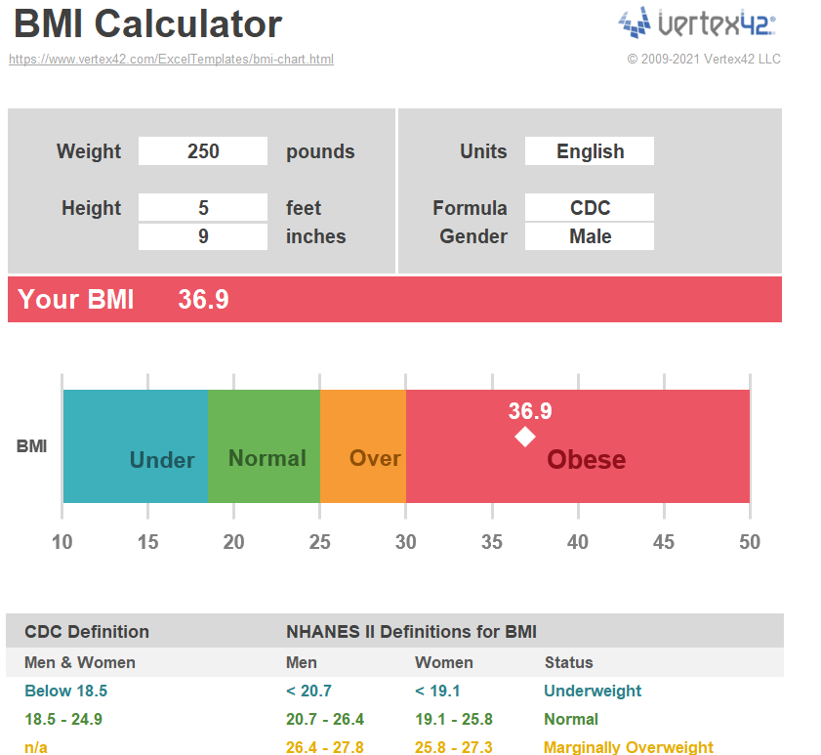

Filters used

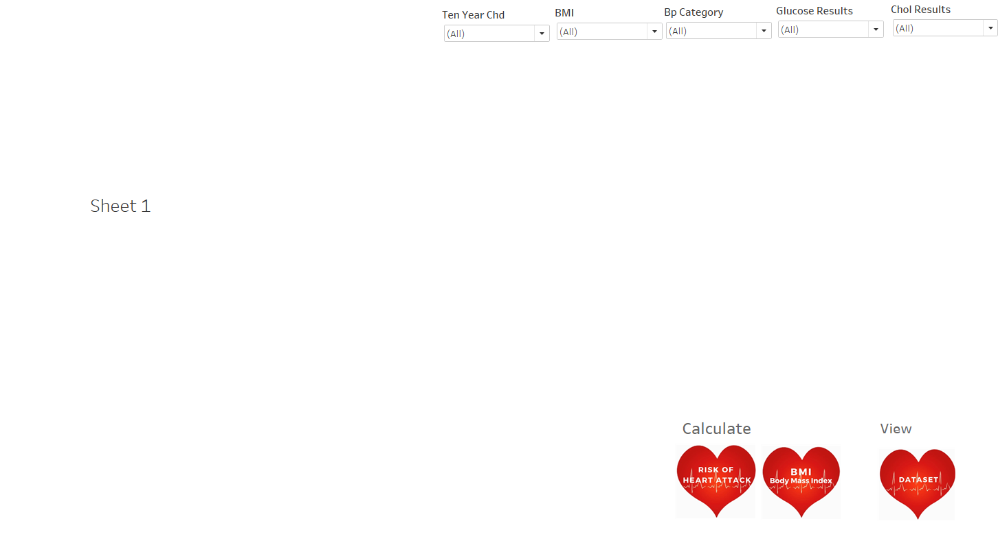

Dashboard and Worksheets

